Expressive Arts Programme
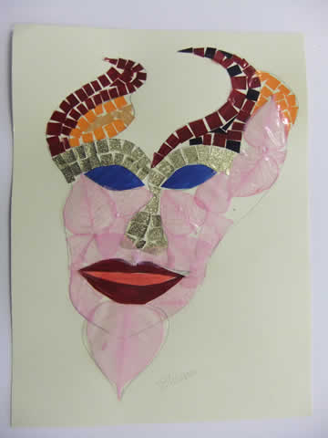
The Lloyds TSB Foundation, England and Wales, currently supported the Tuesday afternoon programme of Expressive Arts workshops which feature a wide variety of media. The programme has also attracted many artists new to working with Borderland Voices.

